**Name (netid):** Johnathon Small (jssmall3)

**CS 445 - Project 2: Image Quilting**

Complete the claimed points and sections below.

**Total Points Claimed [ ] / 175**

**Core**

1. Randomly Sampled Texture [10] / 10
2. Overlapping Patches [20] / 20
3. Seam Finding [20] / 20
4. Additional Quilting Results [10] / 10
5. Texture Transfer [ ] / 30
6. Quality of results / report [ ] / 10

**B&W**

1. Iterative Texture Transfer [ ] / 15
2. Face-in-Toast Image [ ] / 20
3. Hole filling w/ priority function [ ] / 40

**1. Randomly Sampled Texture**

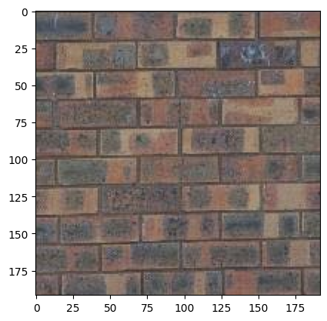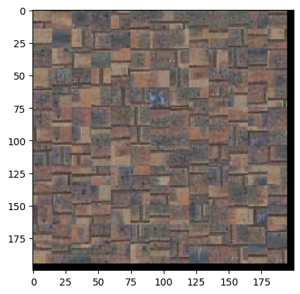

The images above were generated with a target output size of 200x200 and a patch size of 15. Random patches were taken from the texture (left) and used to assemble a new texture (right). The brick pattern has a lot of proportion data that matters at a more macro scale, which leads to the poor reproduction in the output image as edges do not line up meaningfully.

**2. Overlapping Patches**

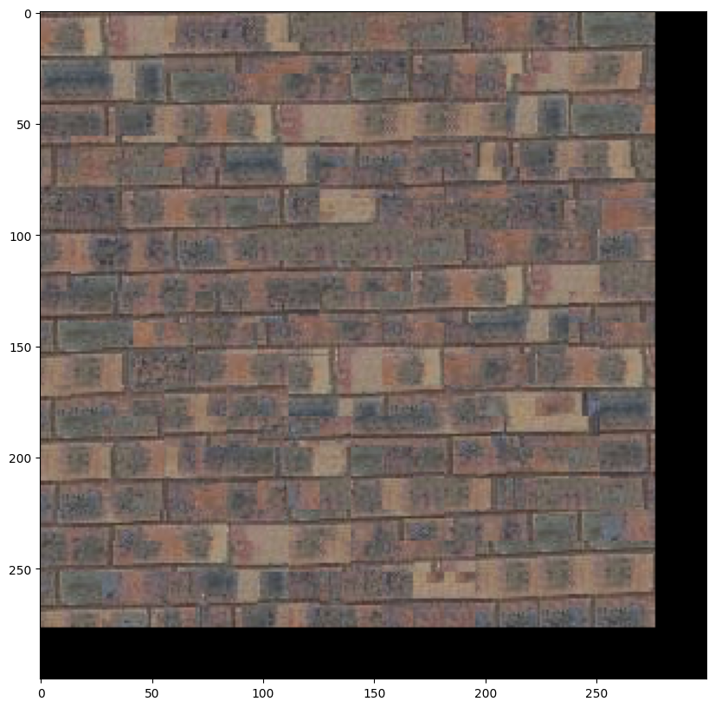

This image was generated with a patch size of 25, overlap of 11, and tolerance of 5. It preserves significantly more of the low frequency information from the input texture and, from a distance, appears to be a brick pattern. However, there are still misalignments and edges created by the overlapping process that make the result less suitable under close inspection.

**3. Seam Finding**

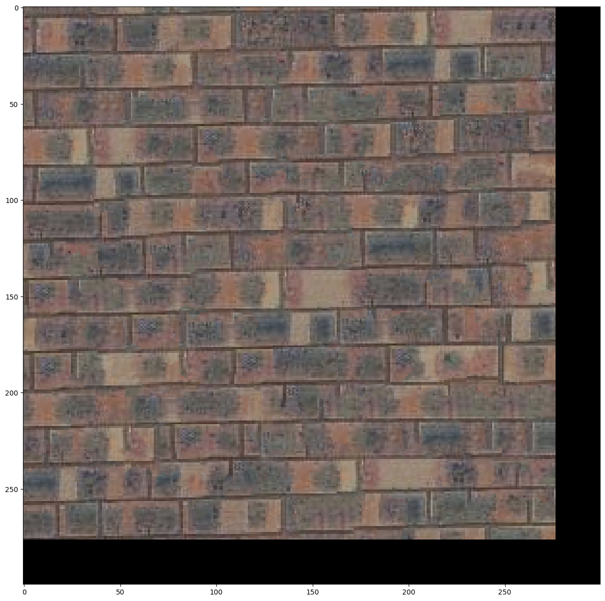

The overlapping patches algorithm from above was edited simply to call a customized cut function prior to adding the patch to the image. Parameters were kept the same (patch_size=25, overlap=11, tolerance=5). This customized function computes the error surface as described in Efros & Freeman (2001), then uses the provided utils.cut function to obtain the cut mask, which is composited for both directions, applied to the sample & template patches, and returned. Results for each of these steps are shown below:

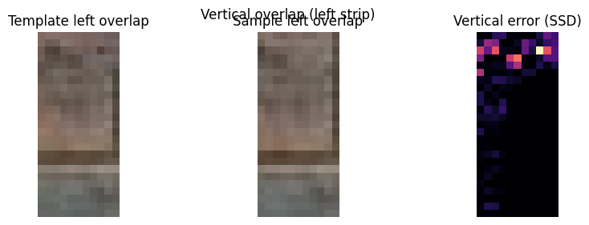

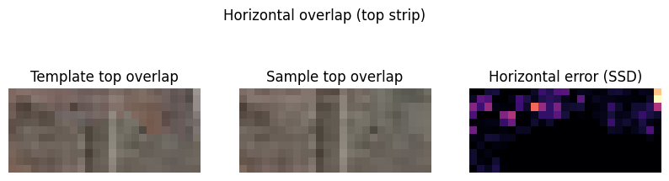

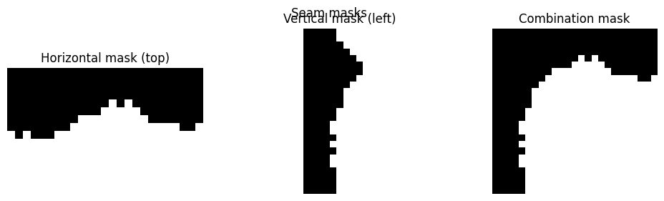

**4. Additional Quilting Results**

Input image is a tablecloth patch 250x250 (scaled down from a 1000x1000 patch to increase density of detail). Output is generated at 500x500. Parameters for both additional results were kept at patch size 25, overlap 11, and tolerance 5. Reproduction was quite convincing; though certain floral elements lost their original shape, they still appeared to belong in the pattern. The sample and patch size were not large enough to capture the repeating pattern in the textile, so relative positions of elements were not retained.

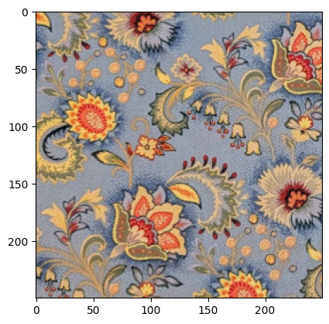 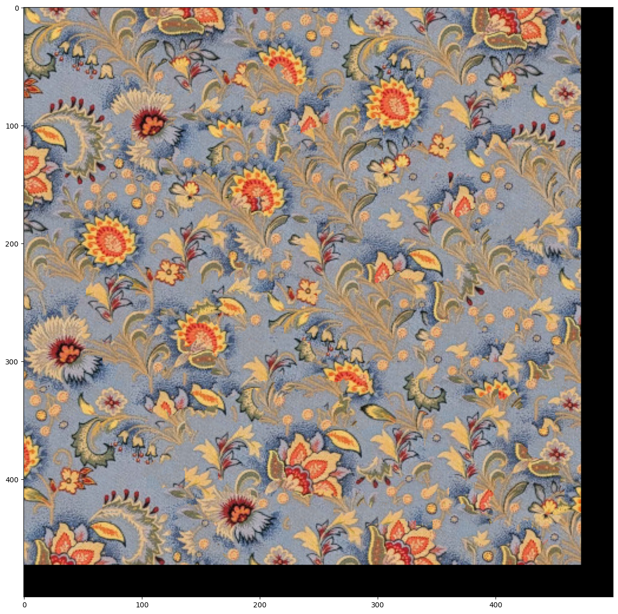

The second image is wood grain, again sampled at 1000px square and scaled down to 250px scare, then synthesized at a size of 500px square. This texture is more stochastic and provides a very convincing result with no visible seams or distortions.

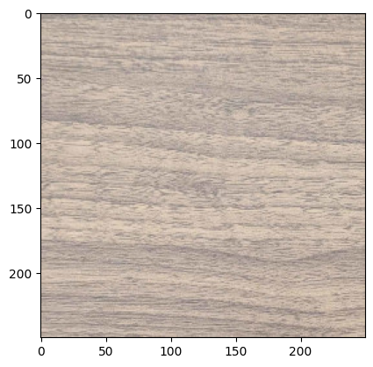

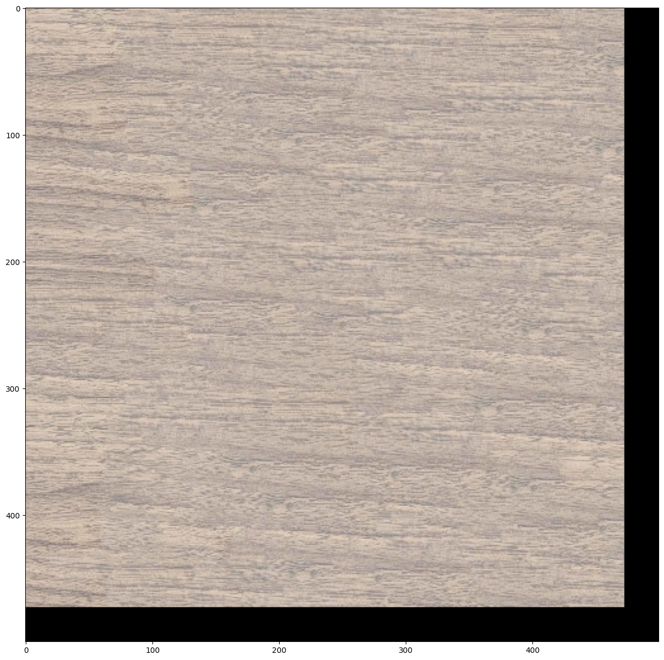

**5. Texture Transfer**

Include

* Brief description of texture transfer method and parameters
* At least two texture transfer results (one result can use provided samples). Include the input texture and target images and the output (output should be same size as target image)

**6. Quality of results / report**

Nothing extra to include (scoring: 0=poor 5=average 10=great).

**7. Iterative Texture Transfer (B&W)**

Include

* Describe method
* Results on same images as shown for texture transfer.

**8. Face-in-Toast Image (B&W)**

Include

* Describe method
* Show input face image, toast image, and final result

**9. Hole filling w/ priority function (B&W)**

Include

* Describe method
* Show result on at least two images (show input with hole and output)

**Acknowledgments / Attribution**

List any sources for code or images from outside sources

AI (ChatGPT) was used for some of the image display code (matplotlib) to get more attractive results (e.g. for seam finding images). All other code is mine.